**IT2100 Programming Logic**

**Capstone Project**

***CAPSTONE***

This project will become part of your portfolio.

This is your capstone project. It becomes as part of your portfolio to demonstrate what you have learned to future employers or graduate schools. Your graded capstone project submission will be appended to this project assignment and saved as part of your permanent portfolio.

Place the paragraph on the next page at the top of your submission:

IT 2100, Programming Logic, is a second semester freshman year course.

COURSE DESCRIPTION:

This is the first of a three course programming sequence. This course introduces programming concepts in a programming language agnostic environment and includes basic algorithm design and development including arrays and the three basic programming structures; sequence, decision, and repetition. It also includes preparing self-documenting programs with appropriate program comments.

Programming Logic introduces computer memory usage as part of primitive and abstract variables and data types.

In addition, this course introduces basic problem analysis skills that aid the student when developing algorithms.

.

**Capstone Project**

For this project, you will design and implement a series of tasks for your scribbler robot. For each exercise,

1. You must prepare a statement of requirements.
2. Your program is a design. You must preserve your original program.
3. You should identify the shortcomings in your original design (if any).
4. You must produce a final design showing the final program you implemented.
5. You must produce a video, with audio, demonstrating how your robot completes this challenge.
6. You must upload your final Capstone to GitHub

**Exercise 1 — Traverse A Maze**

1. The Exercise
   1. Associated with this sheet is a maze. Build this maze using anything you have handy (you could even draw it) – it is not to scale; you can take liberties and add more, if you wish.
   2. Develop a program that traverses this maze.
   3. Follow any rules shown on the maze.
   4. Be sure you use proper programming, including sequence, decisions, loops, and subs. Your grade will be heavily determined by how well structured the program is. A “brute force” program will not earn a passing grade.
   5. You may not create a line that traverses your maze and have the Scribbler follow that line.
   6. Save your program as ***yourLastName***­.**capstone.E1**

**Exercise 2 — Adding Lights**

1. The Exercise
2. Copy your program from **capstone.E1** – rename the copy **yourLastName.capstone.E2**
   1. modify only **yourLastName.capstone.E2** for this part.
   2. you must hand in both **yourLastName.capstone.E1** and **yourLastName.capstone.E2** to have the possibility of receiving full credit for this project.
3. This time
   1. When Scribbler turns right, light only the right LED
   2. When Scribbler turns left, light only the left LED
   3. When Scribbler is going straight, light only the center LED
4. This time, as Scribbler completes each of the requirements, play a song of triumph.
5. Upon completion, design and implement a completion dance that includes motion, lights, and sound.
6. Save this program as ***yourLastName*.capstone.E2**

**Deliverables:**

* 1. Your requirements.

Your grade will be based on your description of the requirements to complete the programming portion of this assignment

* 1. Your initial design.
     1. A listing of any shortcomings in the original design – or a statement that the original design had no deficiencies.
     2. Your final design.

Your grade will be based on your design, what went wrong or right, and how you fixed problems

* 1. A video of your Scribbler traversing your maze that shows the LEDs turning on and off and allows a listener to hear sounds emanating from Scribbler.

Grading Criteria:

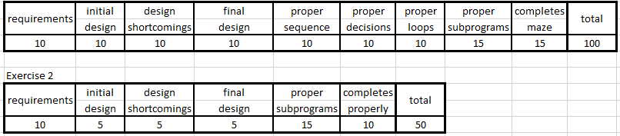

There will be significant penalties for not following directions!

|  |  |  |  |
| --- | --- | --- | --- |
| Exercises not named properly | folder not named properly | zipped folder not named properly | did not follow directions |
|
|
| each | each | each | up to |
| -40 | -40 | -40 | -80 |

* 1. Upload to GitHub
     1. Upload all three parts of your Capstone to GitHub

Your grade will be based on whether or not you uploaded all three parts and how well you instruct me as to how to retrieve them for viewing.